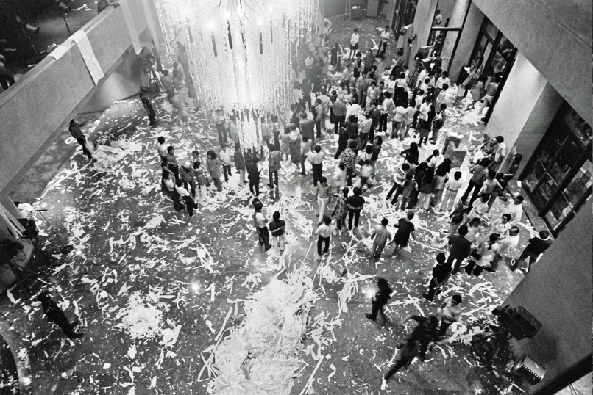

Figure 1.1 Jose Maceda, *Cassettes 100* aftermath, March 8, 1971, performance, Cultural Center of the Philippines lobby (Photograph by Nathaniel Gutierrez)

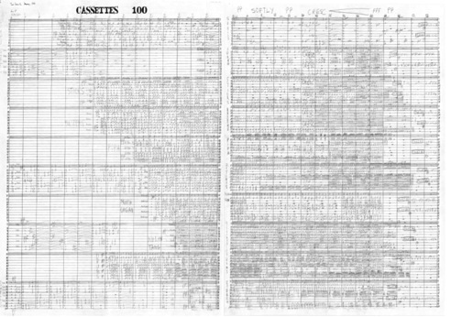

Figure 1.2. First Two Pages of *Cassettes 100* Score, Jose Maceda, 1971 (Courtesy of University of the Philippines-Diliman Department of Ethnomusicology Library and Archives)

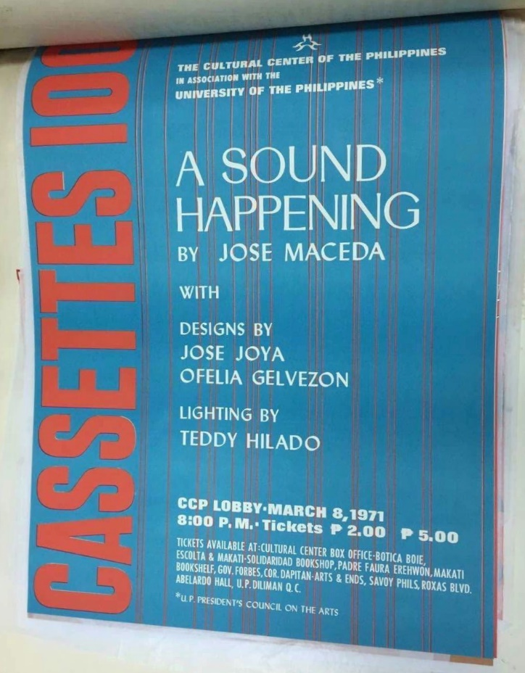

Figure 1.3. Poster for *Cassettes 100* (Courtesy of Cultural Center of the Philippines Library and Archives)

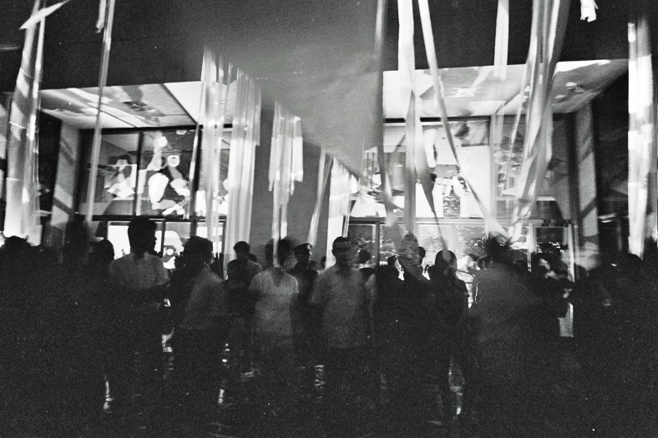

Figure 1.4. Jose Maceda, *Cassettes 100*, March 8, 1971, performance, Cultural Center of the Philippines lobby (Photograph by Nathaniel Gutierrez)

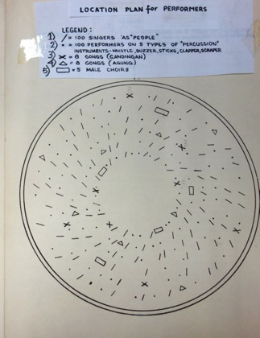

Figure 1.5. *Pagsamba* Diagram. (Courtesy of University of the Philippines-Diliman Department of Ethnomusicology Library and Archives)

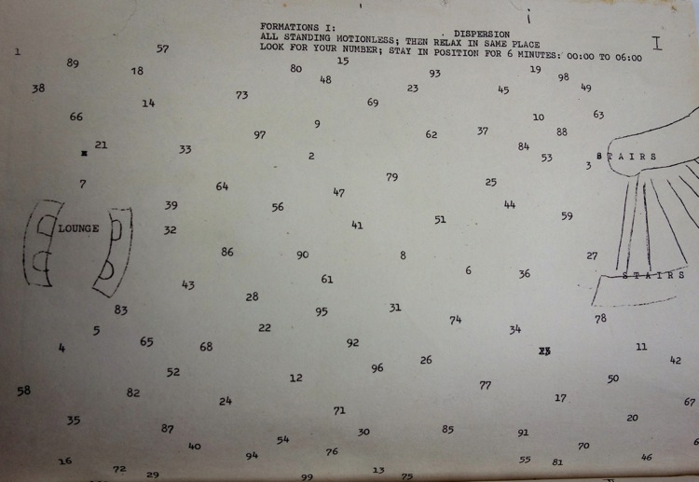

Figure 1.6. Jose Maceda, *Cassettes 100,* “Formations I” diagram documentation (Provided by the Cultural Center of the Philippines)

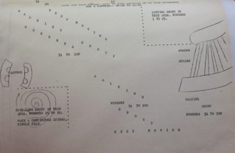

Figure 1.7. Jose Maceda, *Cassettes 100,* “Formations II” diagram documentation (Provided by the Cultural Center of the Philippines)

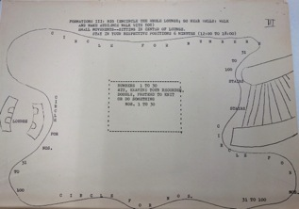

Figure 1.8. Jose Maceda, *Cassettes 100,* “Formations III” diagram documentation (Provided by the Cultural Center of the Philippines)

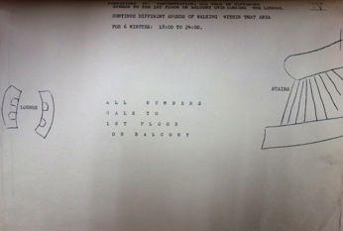

Figure 1.9. Jose Maceda, *Cassettes 100,* “Formations IV” diagram documentation (Provided by the Cultural Center of the Philippines)

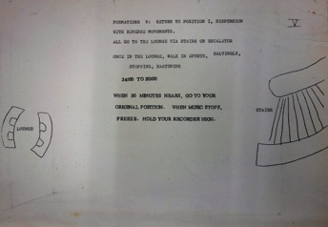

Figure 1.10. Jose Maceda, *Cassettes 100,* “Formations IV” diagram documentation (Provided by the Cultural Center of the Philippines)

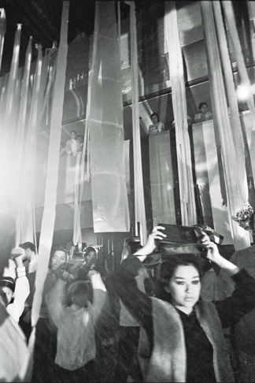

Figure 1.11. Jose Maceda, *Cassettes 100*, March 8, 1971, performance, Cultural Center of the Philippines lobby (Photograph by Nathaniel Gutierrez)

---_0176.tif

Figure 1.12. Jose Maceda, *Cassettes 100*, March 8, 1971, performance, Cultural Center of the Philippines lobby (Photograph by Nathaniel Gutierrez)

---_0054.tif

Figure 1.13. Jose Maceda, *Cassettes 100*, March 8, 1971, performance, Cultural Center of the Philippines lobby (Photograph by Nathaniel Gutierrez)

---_0055.tif

Figure 1.14. Jose Maceda, *Cassettes 100*, March 8, 1971, performance, Cultural Center of the Philippines lobby (Photograph by Nathaniel Gutierrez)

---_0046.tif

Figure 1.15. Jose Maceda, *Cassettes 100*, March 8, 1971, performance, Cultural Center of the Philippines lobby (Photograph by Nathaniel Gutierrez)

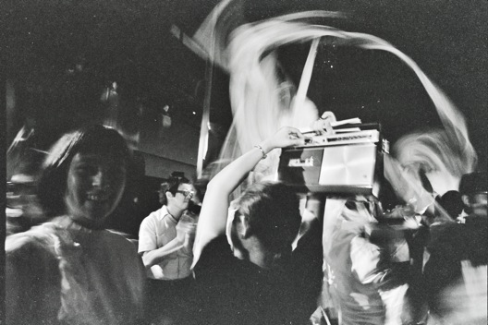

Figure 1.16. Jose Maceda, *Cassettes 100*, March 8, 1971, performance, Cultural Center of the Philippines lobby (Photograph by Nathaniel Gutierrez)

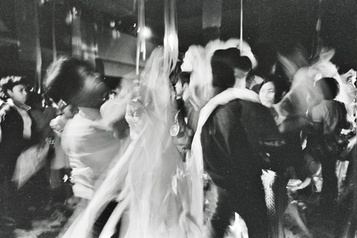

Figure 1.17. Jose Maceda, *Cassettes 100*, March 8, 1971, performance, Cultural Center of the Philippines lobby (Photograph by Nathaniel Gutierrez)

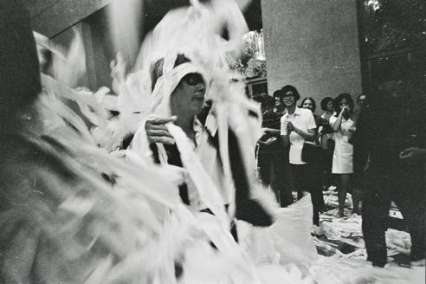

Figure 1.18. Jose Maceda, *Cassettes 100*, March 8, 1971, performance, Cultural Center of the Philippines lobby (Photograph by Nathaniel Gutierrez)

---_0028.tif

Figure 1.19. Jose Maceda, *Cassettes 100*, March 8, 1971, performance, Cultural Center of the Philippines lobby (Photograph by Nathaniel Gutierrez)

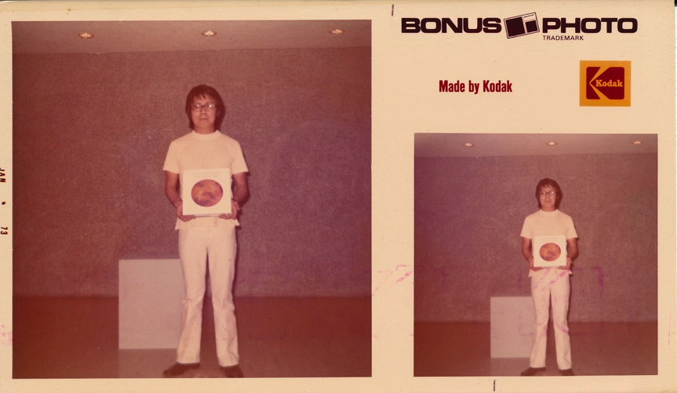

Figure 2.1 Roberto Chabet, *Tearing to Pieces*, performance, Cultural Center of the Philippines, 1973, (Photograph by Yolanda Johnson)



Figure 2.2 Roberto Chabet, *Tearing to Pieces*, performance, Cultural Center of the Philippines, 1973, (Photograph by Yolanda Johnson)

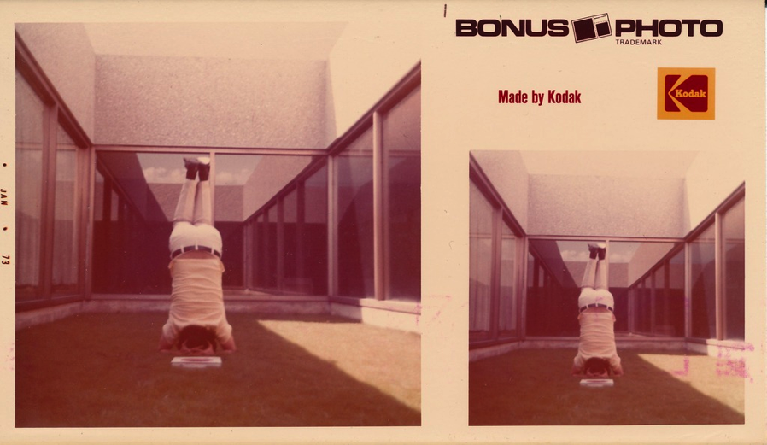

Figure 2.3 Roberto Chabet, *Tearing to Pieces*, performance, Cultural Center of the Philippines, 1973, (Photograph by Yolanda Johnson)



Figure 2.4 Roberto Chabet, *Tearing to Pieces*, performance, Cultural Center of the Philippines, 1973, (Photograph by Yolanda Johnson)

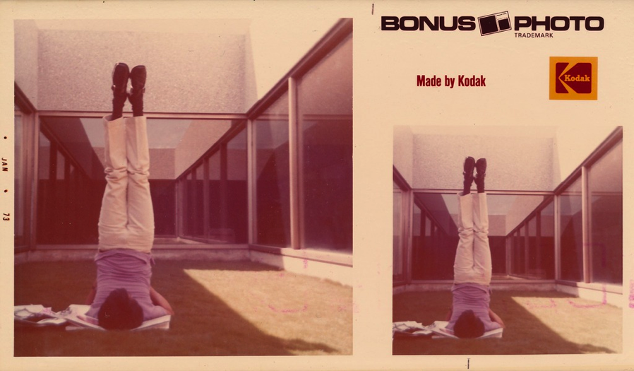

Figure 2.5 Roberto Chabet, *Tearing to Pieces*, performance, Cultural Center of the Philippines, 1973, (Photograph by Yolanda Johnson)

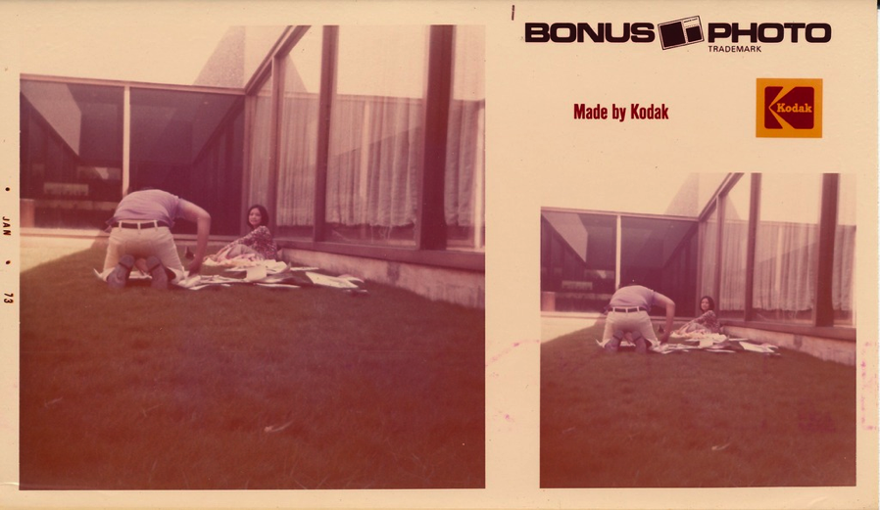

Figure 2.6 Roberto Chabet, *Tearing to Pieces*, performance, Cultural Center of the Philippines, 1973, (Photograph by Yolanda Johnson)

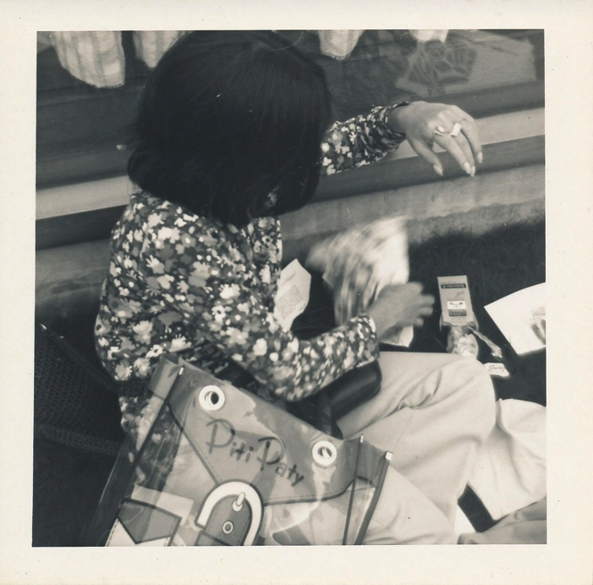

Figure 2.7 Roberto Chabet, *Tearing to Pieces*, performance, Cultural Center of the Philippines, 1973, (Photograph by Yolanda Johnson)

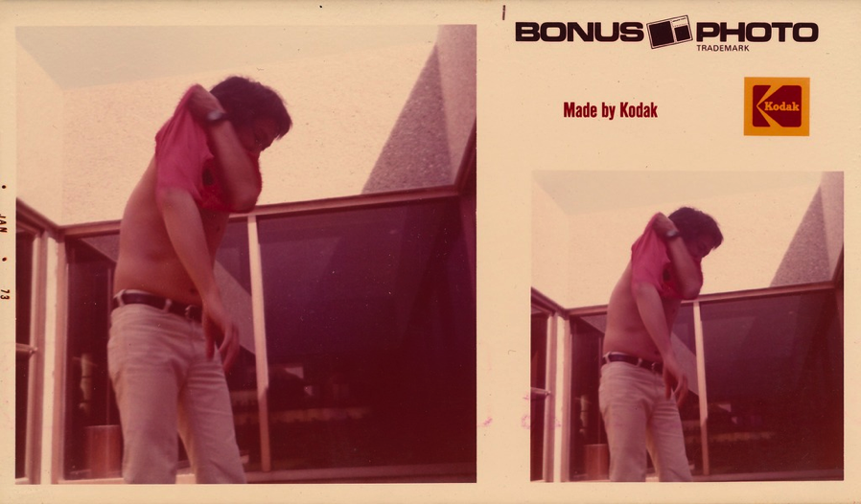

Figure 2.8 Roberto Chabet, *Tearing to Pieces*, performance, Cultural Center of the Philippines, 1973, (Photograph by Yolanda Johnson)

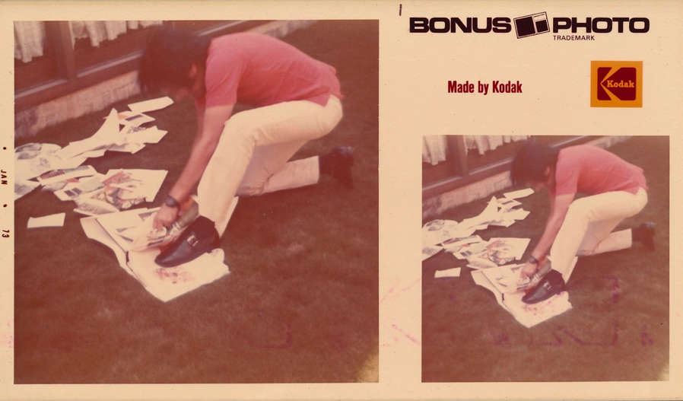

Figure 2.9 Roberto Chabet, *Tearing to Pieces*, performance, Cultural Center of the Philippines, 1973, (Photograph by Yolanda Johnson)

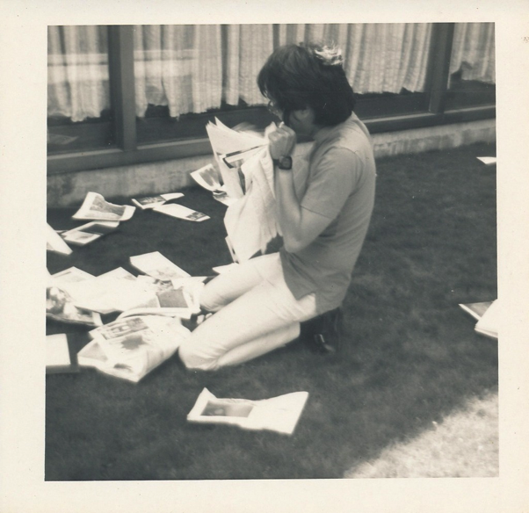

Figure 2.10 Roberto Chabet, *Tearing to Pieces*, performance, Cultural Center of the Philippines, 1973, (Photograph by Yolanda Johnson)

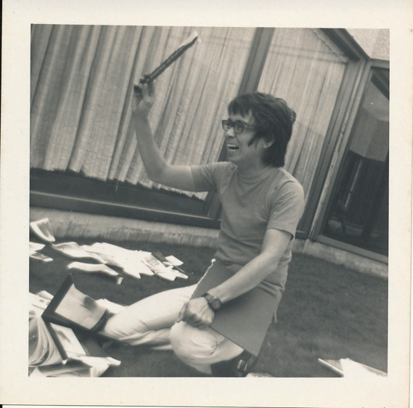

Figure 2.11 Roberto Chabet, *Tearing to Pieces*, performance, Cultural Center of the Philippines, 1973, (Photograph by Yolanda Johnson)

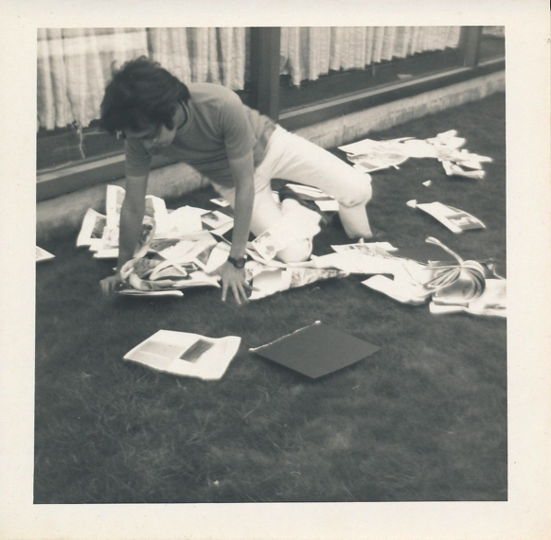

Figure 2.12 Roberto Chabet, *Tearing to Pieces*, performance, Cultural Center of the Philippines, 1973, (Photograph by Yolanda Johnson)

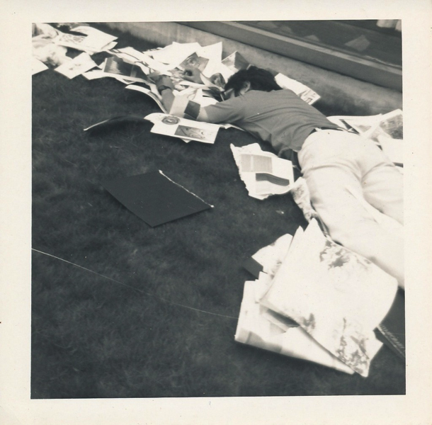

Figure 2.13 Roberto Chabet, *Tearing to Pieces*, performance, Cultural Center of the Philippines, 1973, (Photograph by Yolanda Johnson)

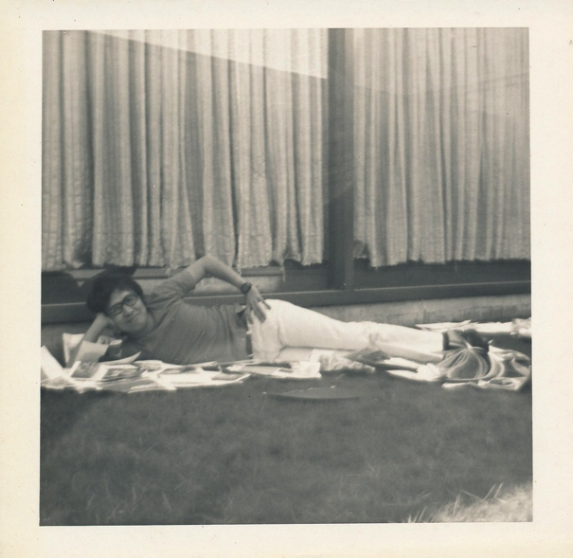

Figure 2.14 Roberto Chabet, *Tearing to Pieces*, performance, Cultural Center of the Philippines, 1973, (Photograph by Yolanda Johnson)

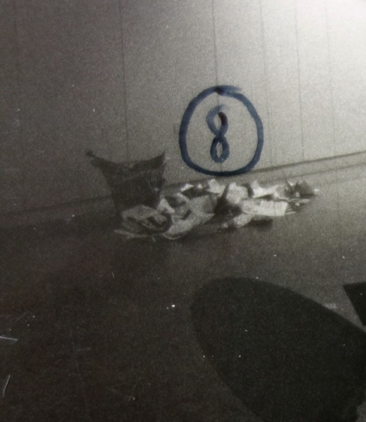

Figure 2.15 Roberto Chabet, Yoli Laudico, and Joy Dayrit, *Tearing to Pieces*, (artists specified medium, “Philippine Contemporary Art”) waste basket, torn pieces of book

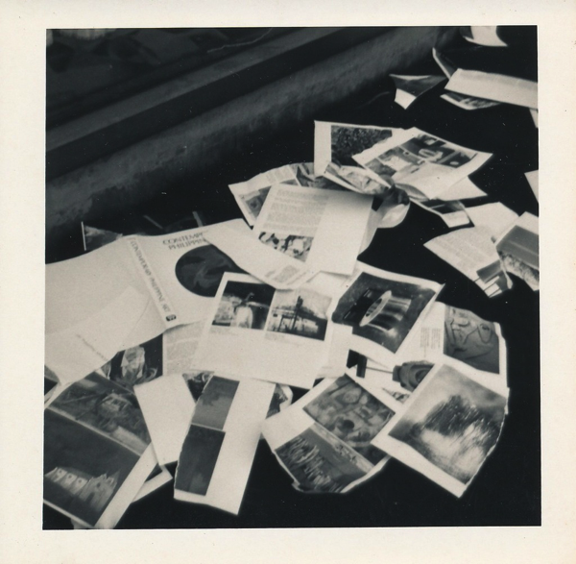

Figure 2.16 Roberto Chabet, *Tearing to Pieces*, performance, Cultural Center of the Philippines, 1973, (Photograph by Yolanda Johnson)

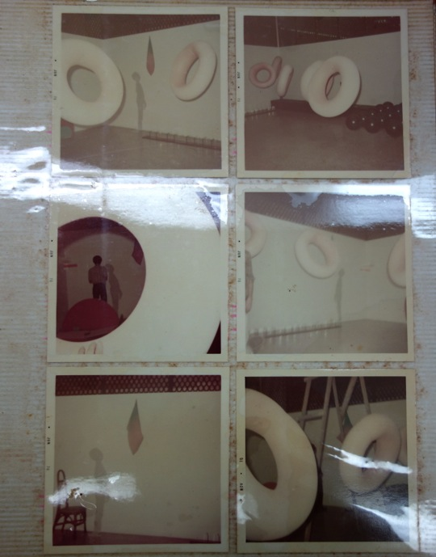

Figure 2.17 Liwayway Recapping Co. photo album leaf from final Print Gallery Exhibition,1970

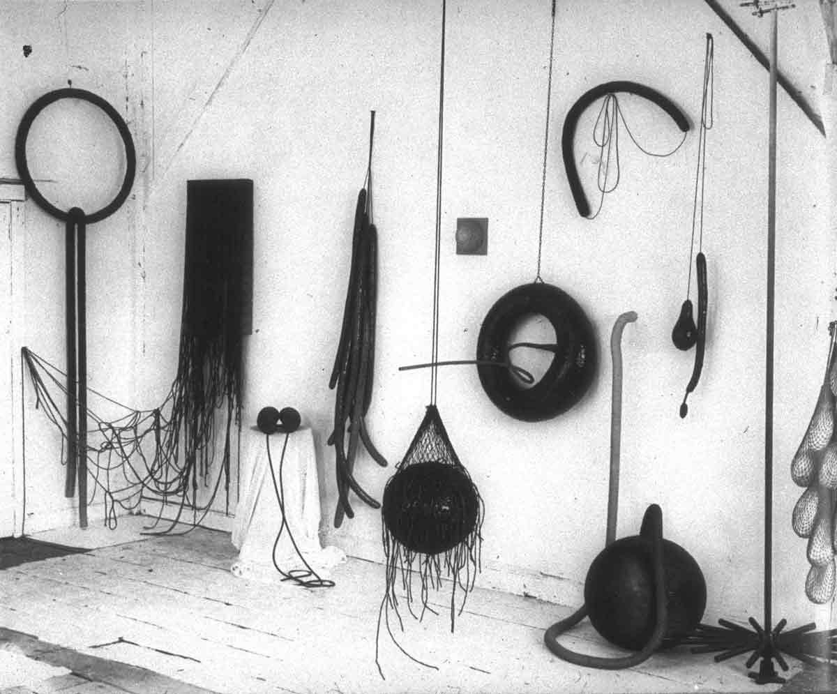

Figure 2.18 Eva Hesse, Photograph of Hesse’s studio, early 1966

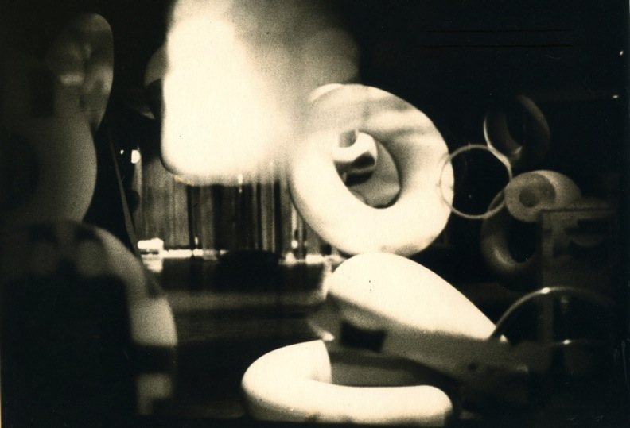

Figure 2.19 Liwayway Recapping Co., *Illuminations*, installation view, Cultural Center of the Philippines, 1970



Figure 2.20 Roberto Chabet, *Kite Traps*, interior tire tube and plywood,1973 (Photograph by Nathaniel Gutierrez)



Figure 2.21 Roberto Chabet, *Kite Traps*, interior tire tube and plywood, 1973 (Photograph by Nathaniel Gutierrez)

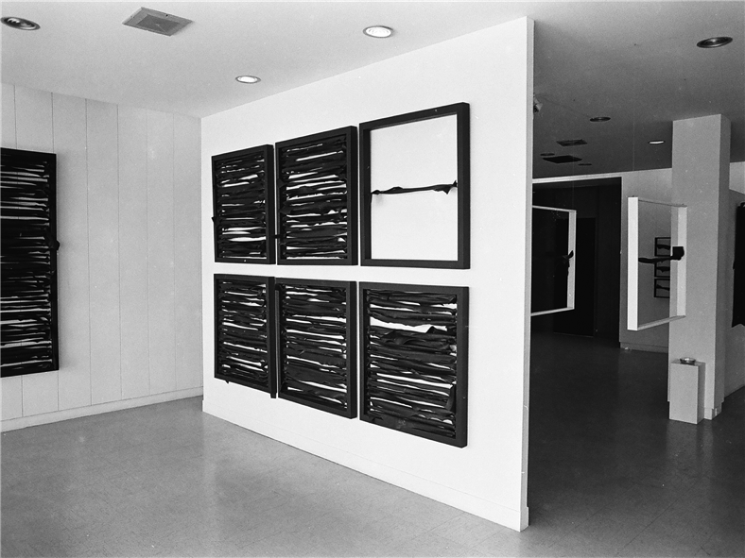

Figure 2.22 Roberto Chabet, *Kite Traps*, installation view at *New Works* (1973), interior tire tube and plywood, 1973

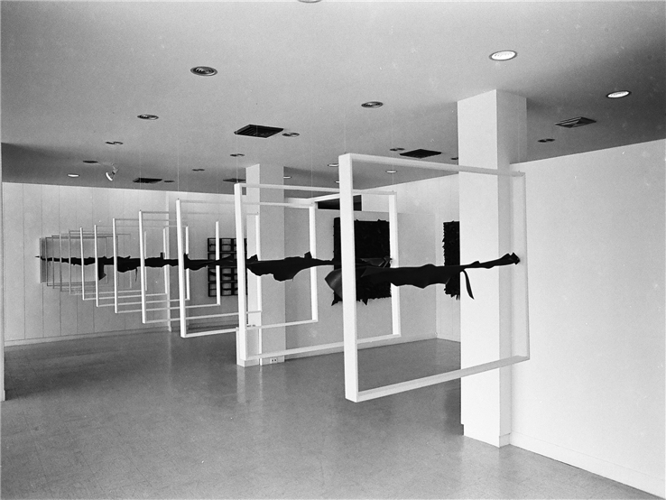

Figure 2.23 Roberto Chabet, *Sky Horizons*, installation view at *New Works* (1973), interior tire tube and plywood, 1973 (Photograph by Nathaniel Gutierrez)

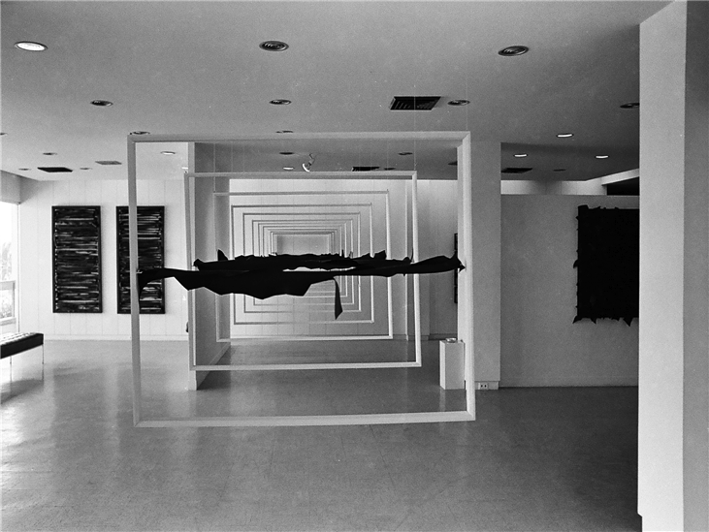

Figure 2.24 Roberto Chabet, *Sky Horizons*, installation view at *New Works* (1973), interior tire tube and plywood 1973 (Photograph by Nathaniel Gutierrez)

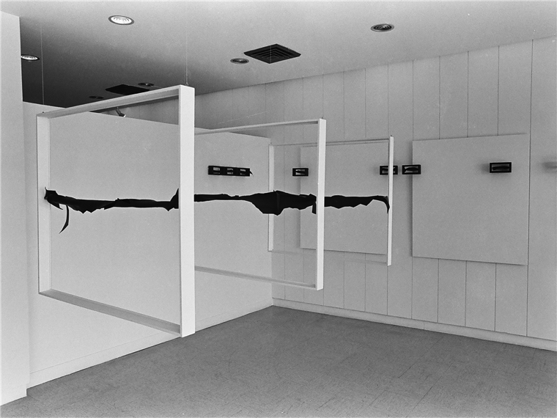

Figure 2.25 Roberto Chabet, *Sky Horizons*, installation view at *New Works* (1973), interior tire tube and plywood, 1973 (Photograph by Nathaniel Gutierrez)

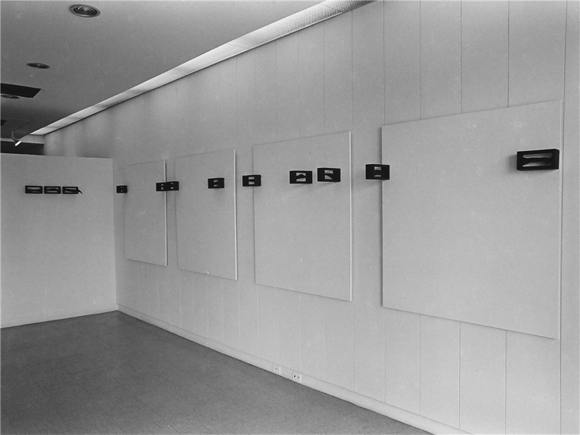

Figure 2.26 Roberto Chabet, *New Works* exhibition view (1973), 1973 (Photograph by Nathaniel Gutierrez)

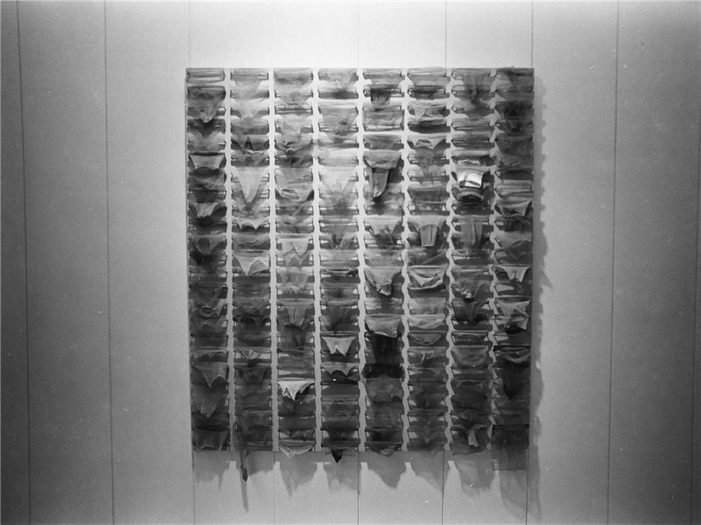

Figure 2.27 Roberto Chabet, *Pink Painting*, nylon stockings on plywood, 1973 (Photograph by Nathaniel Gutierrez)

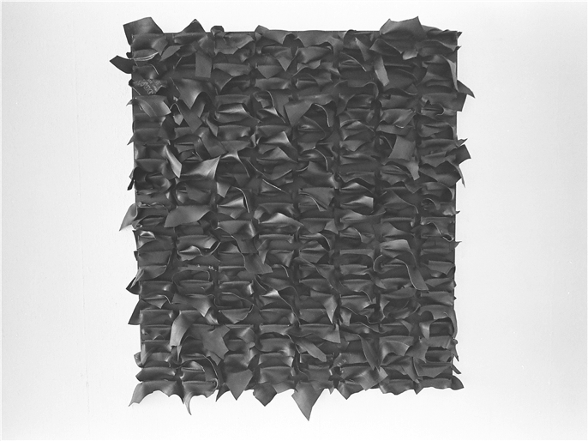

Figure 2.28 Roberto Chabet, no title, interior tire tube and plywood 1973 (Photograph by Nathaniel Gutierrez)

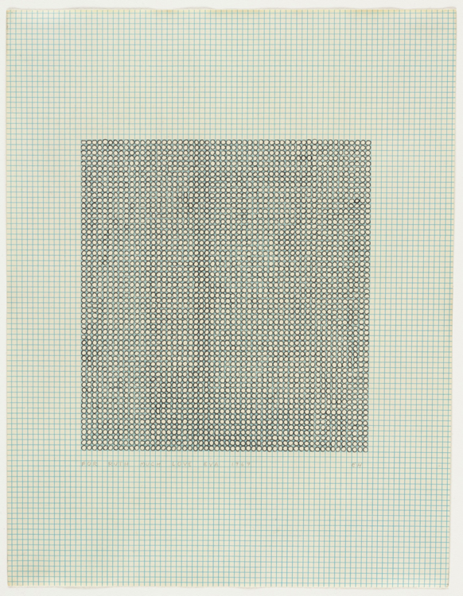

Figure 2.29 Eva Hesse, *No Title*, ink on graph paper, 11 7/8 x 8 1/4”, 1967

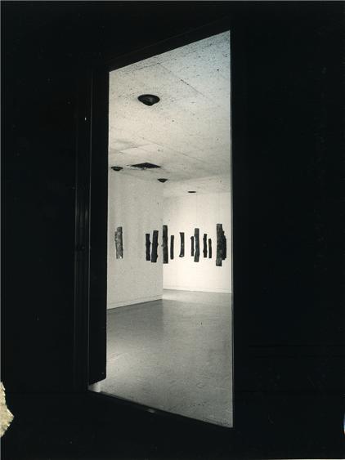

Figure 2.30 Roberto Chabet, *Bakawan*, installation view (1974), 1974 (Photograph by Nathaniel Gutierrez)

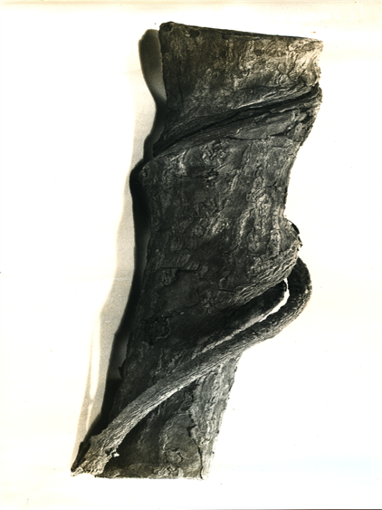

Figure 2.31 Photograph of single *Bakawan*, 1974

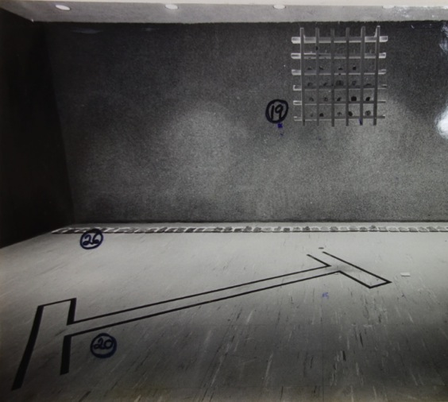

Figure 3.1 Yolanda Laudico, *This is How Air is Strained*, 1973, Installation View at *Summer Exhibition 1973* at the Cultural Center of the Philippines (Photograph by Nathaniel Gutierrez)

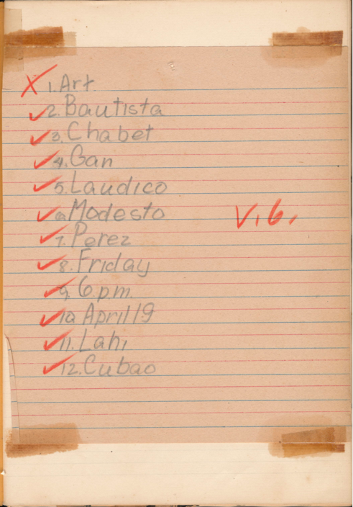

Figure 3.2 Handwritten Invitation to *Basta Ganon Hindi*

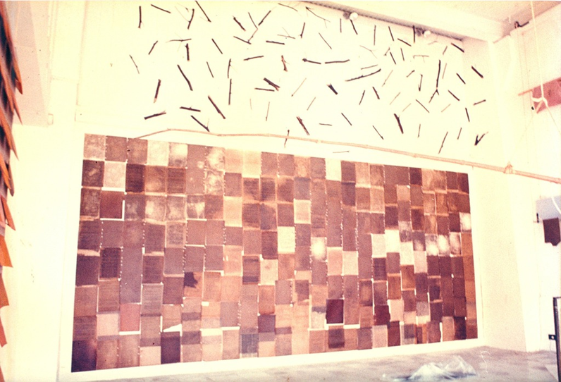

Figure 3.3 Yolanda Laudico, Untitled (Oil Painting), 1974, Installation View at *Basta Ganon Hindi* at Lahi Gallery (Photograph courtesy Yolanda Laudico)

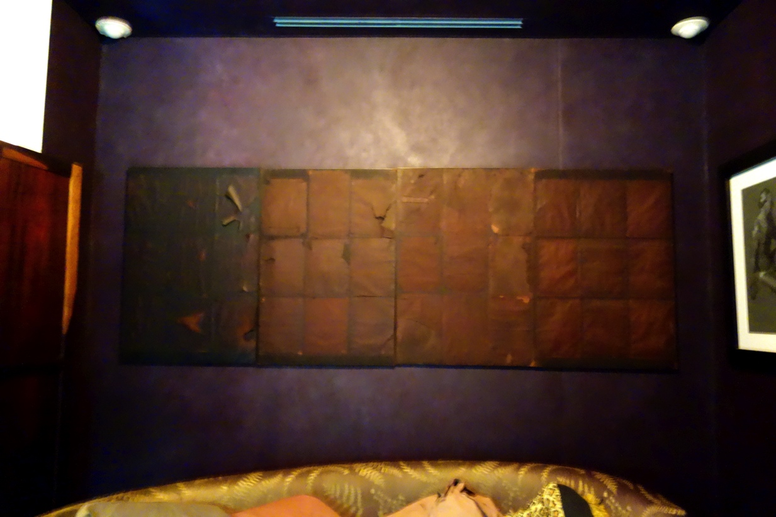

Figure 3.4. Yolanda Laudico, Untitled Oil Painting, In-House Installation

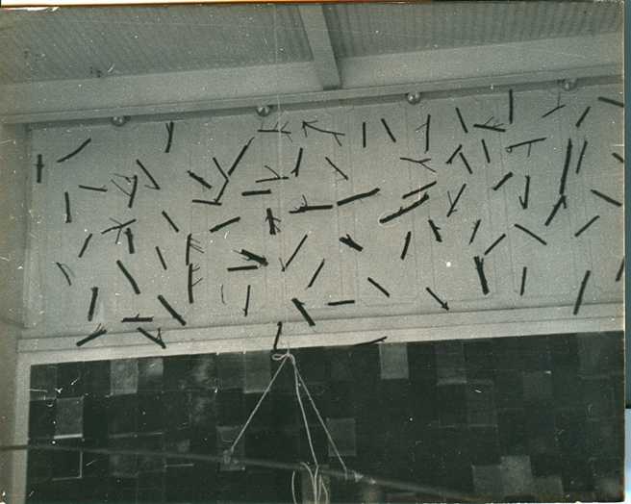

Figure 3.5 Yolanda Laudico, Untitled (Twigs), 1974, Installation View at *Basta Ganon Hindi* at Lahi Gallery (Photograph courtesy Yolanda Laudico)

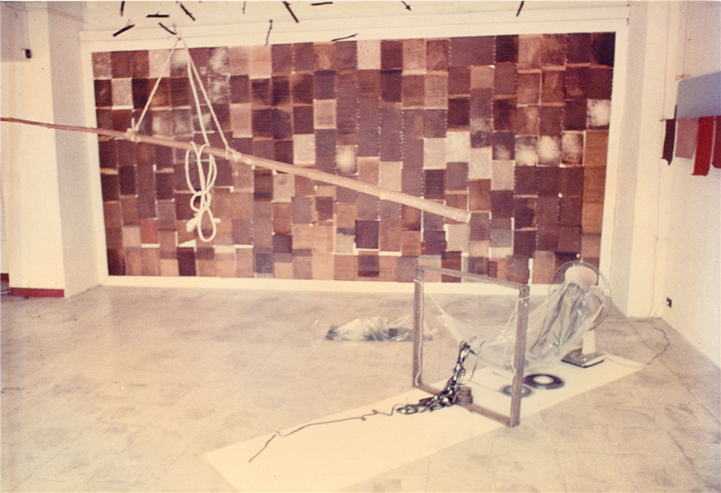

Figure 3.6 Fernando Modesto, Untitled (Fan), 1974, Installation View at *Basta Ganon Hindi* at Lahi Gallery (Photograph courtesy Yolanda Laudico)

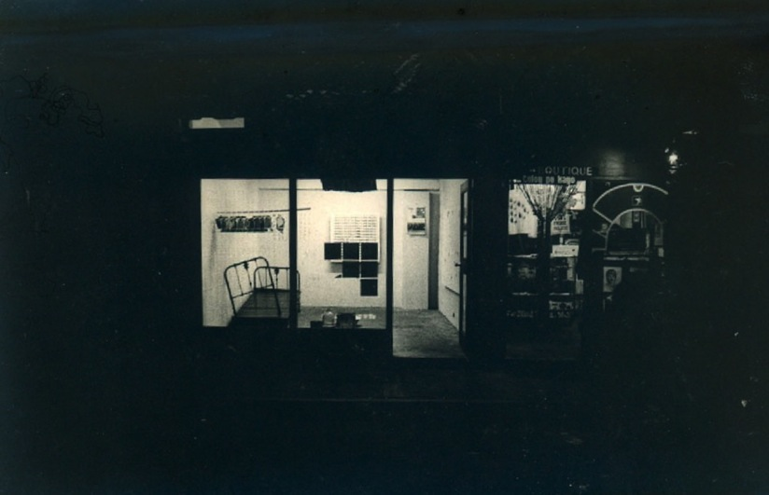

Figure 3.7 Shop 6 Inaugural Group Exhibition, External View, Shop 6 at Sining Kamalig, 1974

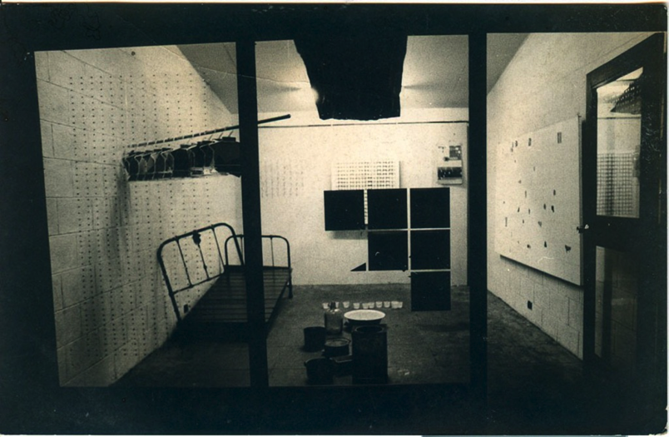

Figure 3.8 Shop 6 Inaugural Group Exhibition, External View, Shop 6 at Sining Kamalig, 1974.

On the left window: Joe Bautista, *Mais* (partial view), mongo seeds, 1974.

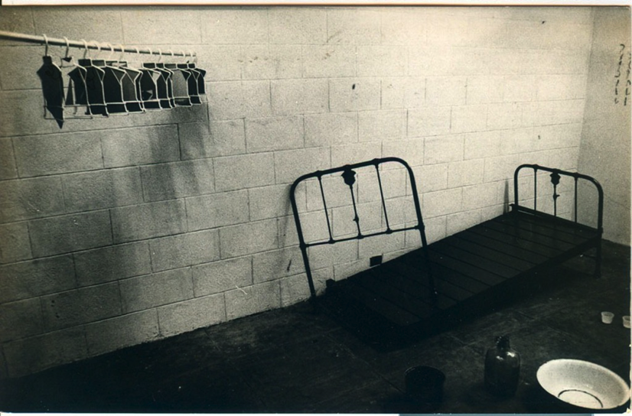

Figure 3.9 Installation View at Shop 6 Inaugural Group exhibition, Shop 6 at Sining Kamalig, 1974: Alan Rivera, *Untitled* (Hangers), 1974; Red Mansueto, *Untitled* (Bed), 1974, Partial View: Danny Dalena, *Untitled* (vessels), 1974; Joe Bautista, *Mais*, 1974

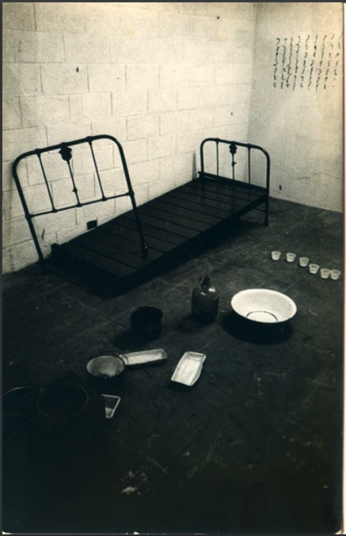

Figure 3.10 Installation View at Shop 6 Inaugural Group exhibition, Shop 6 at Sining Kamalig, 1974: Red Mansueto, *Untitled* (Bed), 1974, Danny Dalena, *Untitled* (vessels), Partial View: 1974; Joe Bautista, *Mais*, 1974

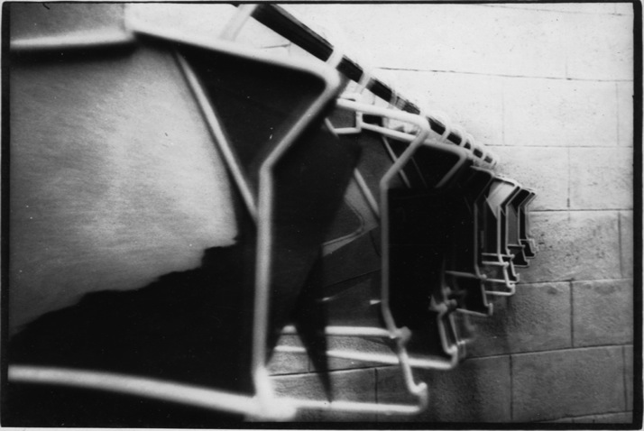

Figure 3.11 Alan Rivera, Untitled (Clothing Hangers), 1974, Installation View at Shop 6 Inaugural Group exhibition, Shop 6 at Sining Kamalig, 1974

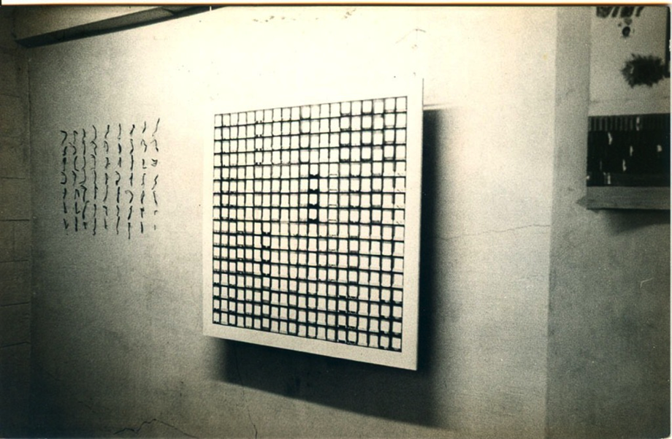

Figure 3.12 Installation View at Shop 6 Inaugural Group exhibition, Shop 6 at Sining Kamalig, 1974: Yolanda Laudico, *Untitled* (Photo-Me ID machine grid), 1974, Partial View: Joe Bautista, *Mais*, 1974

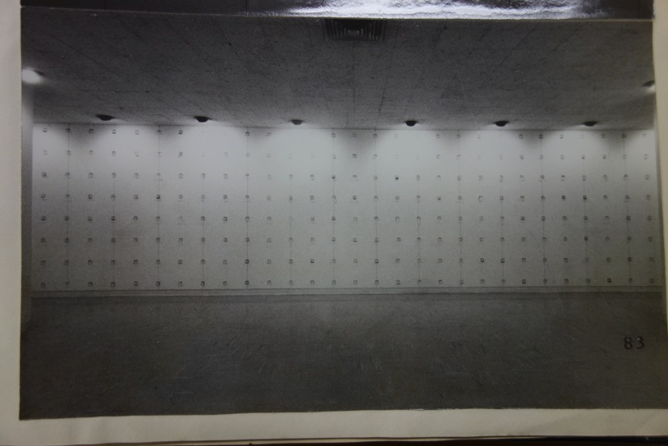

Figure 3.13 *Exhibition I* (From *An Exhibition of Three Works*)Yolanda Laudico, Installation View at Cultural Center of the Philippines, 1975

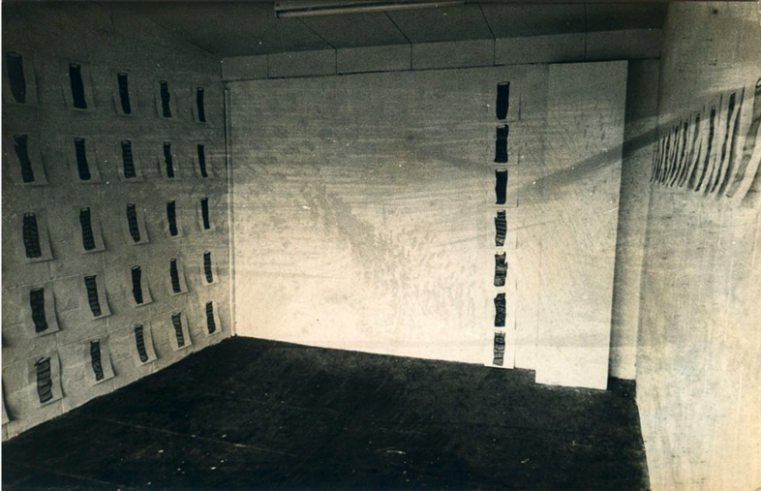

Figure 3.14 Roberto Chabet, *Bakawan Drawings*, 1974, Installation View at Shop 6 Sining Kamalig

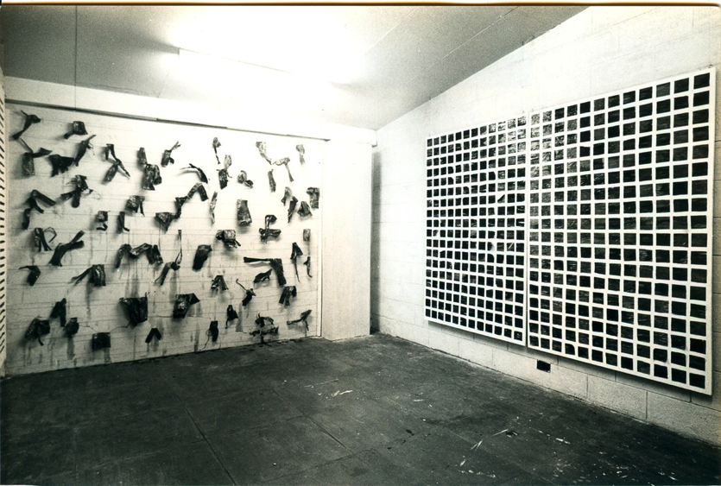

Figure 3.15. Yolanda Laudico, Installation View from Shop 6 Solo Exhibition, 1974

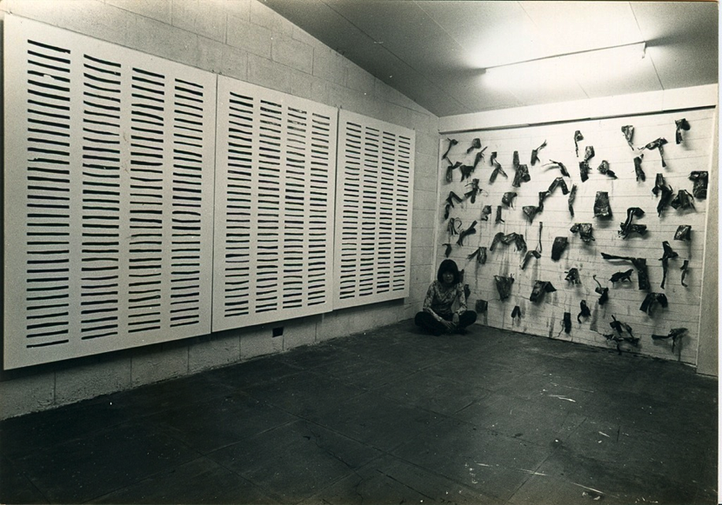

Figure 3.16 Yolanda Laudico, Installation View from Shop 6 Solo Exhibition, 1974

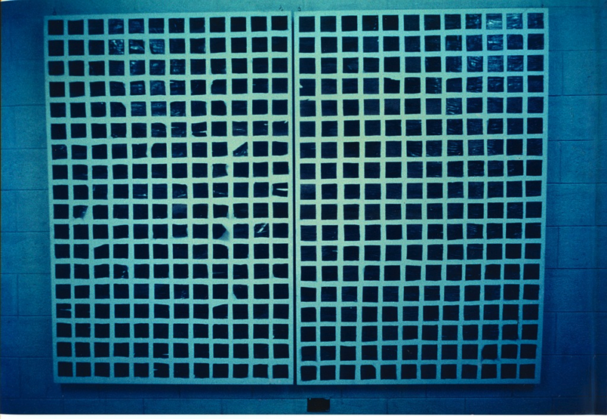

Figure 3.17 Yolanda Laudico, Installation View from Shop 6 Solo Exhibition, 1974

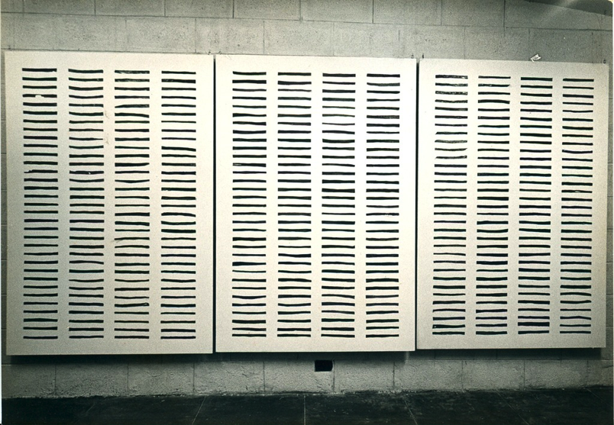

Figure 3.18 Yolanda Laudico, Installation View from Shop 6 Solo Exhibition, 1974

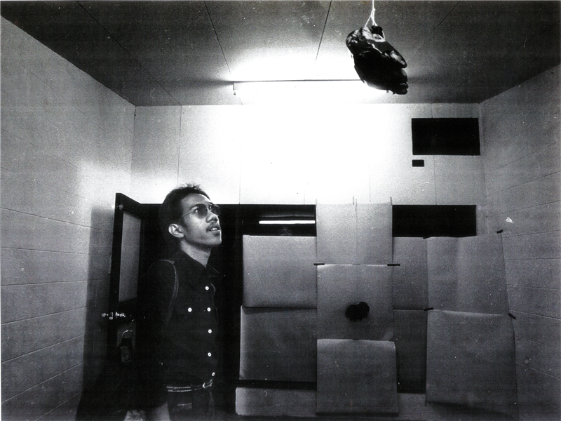

Figure 3.19 Fernando Modesto, *Banana Installation*, January 24, 1975

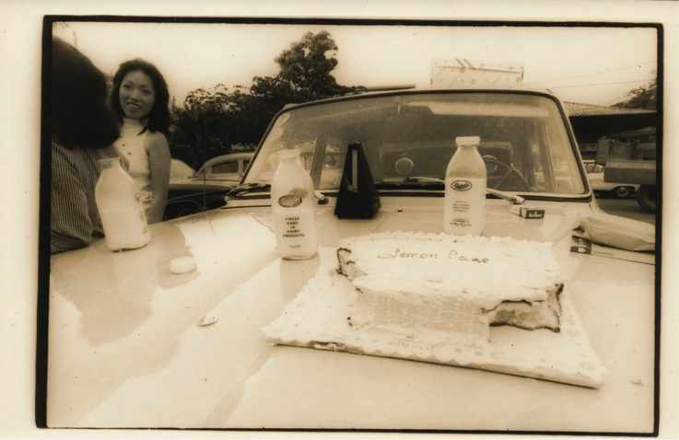

Figure 3.20 Judy Sibayan, *Lemon Cake*, 1974

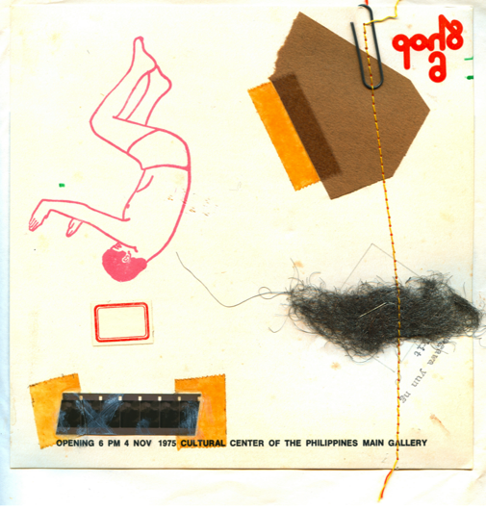

Figure 3.21 *Shop 6* Exhibition Invitation

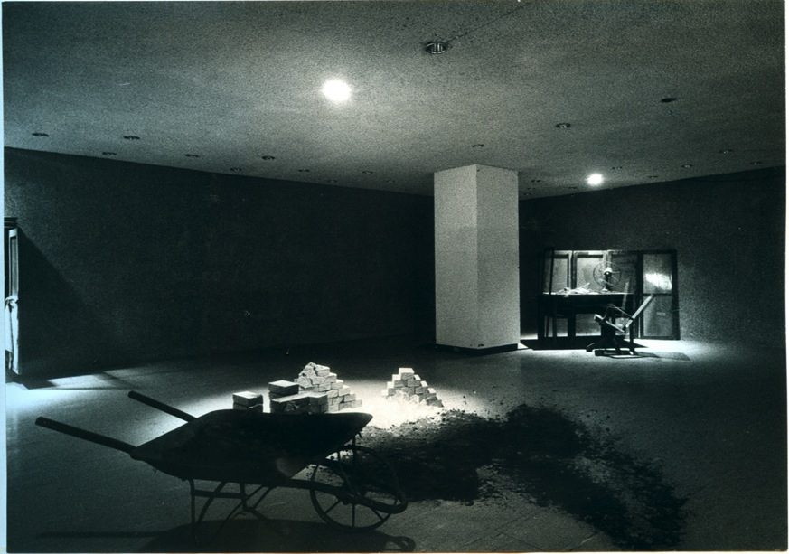

Figure 3.22 Alan Rivera, *Room/Riddles*, Installation View at *Shop 6* Exhibition at the CCP Main Gallery, 1975.

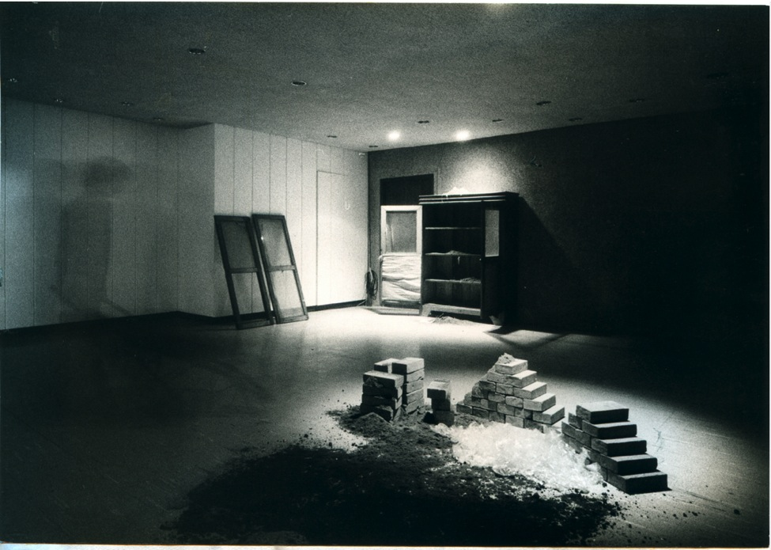

Figure 3.23 Alan Rivera, *Room/Riddles*, Installation View at *Shop 6* Exhibition at the CCP Main Gallery, 1975.